Square Bipyramid

Definition
# Source: AI Source: Provided by: [Data Path: Persons Table -> ID Column: 1, Name_En Column: Motasem Essam] -> From: [ChatGPT] on [7/25/2026]
A Square Bipyramid is a convex polyhedron formed by joining two square-based pyramids along a common square base, with their apexes positioned on opposite sides of the shared base.
It consists of 8 triangular faces, 12 edges, and 6 vertices.
When the two pyramids are congruent and arranged symmetrically, the resulting solid is an Octahedron. When all eight triangular faces are equilateral, it is a Regular Octahedron, one of the five Platonic solids.

Simple Definition
# Source: AI Source: Provided by: [Data Path: Persons Table -> ID Column: 1, Name_En Column: Motasem Essam] -> From: [ChatGPT] on [7/25/2026]
A square bipyramid is a three-dimensional solid formed by joining two square pyramids base-to-base, creating two opposite apexes and four vertices around the middle.
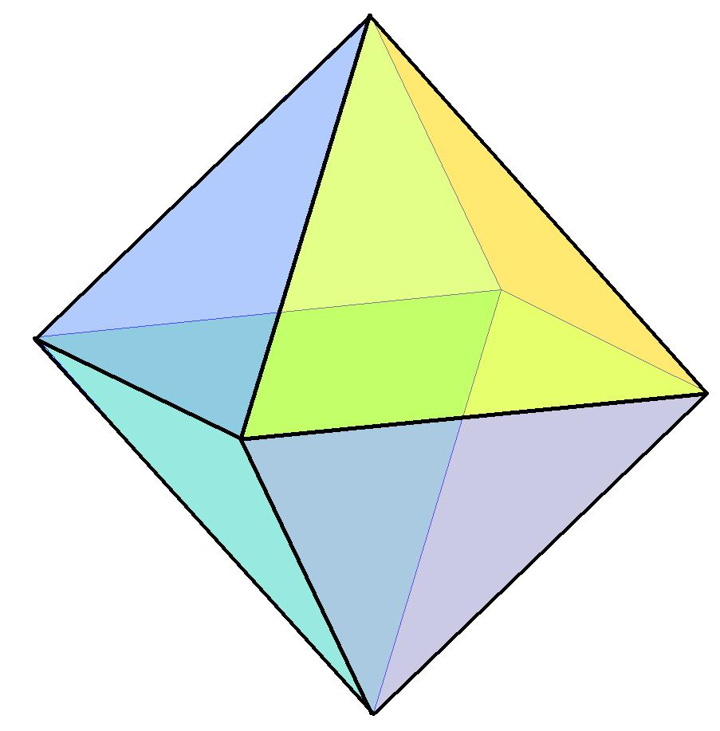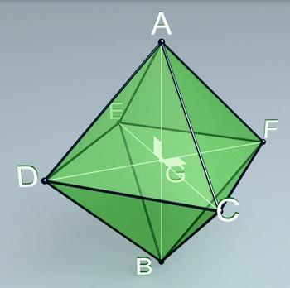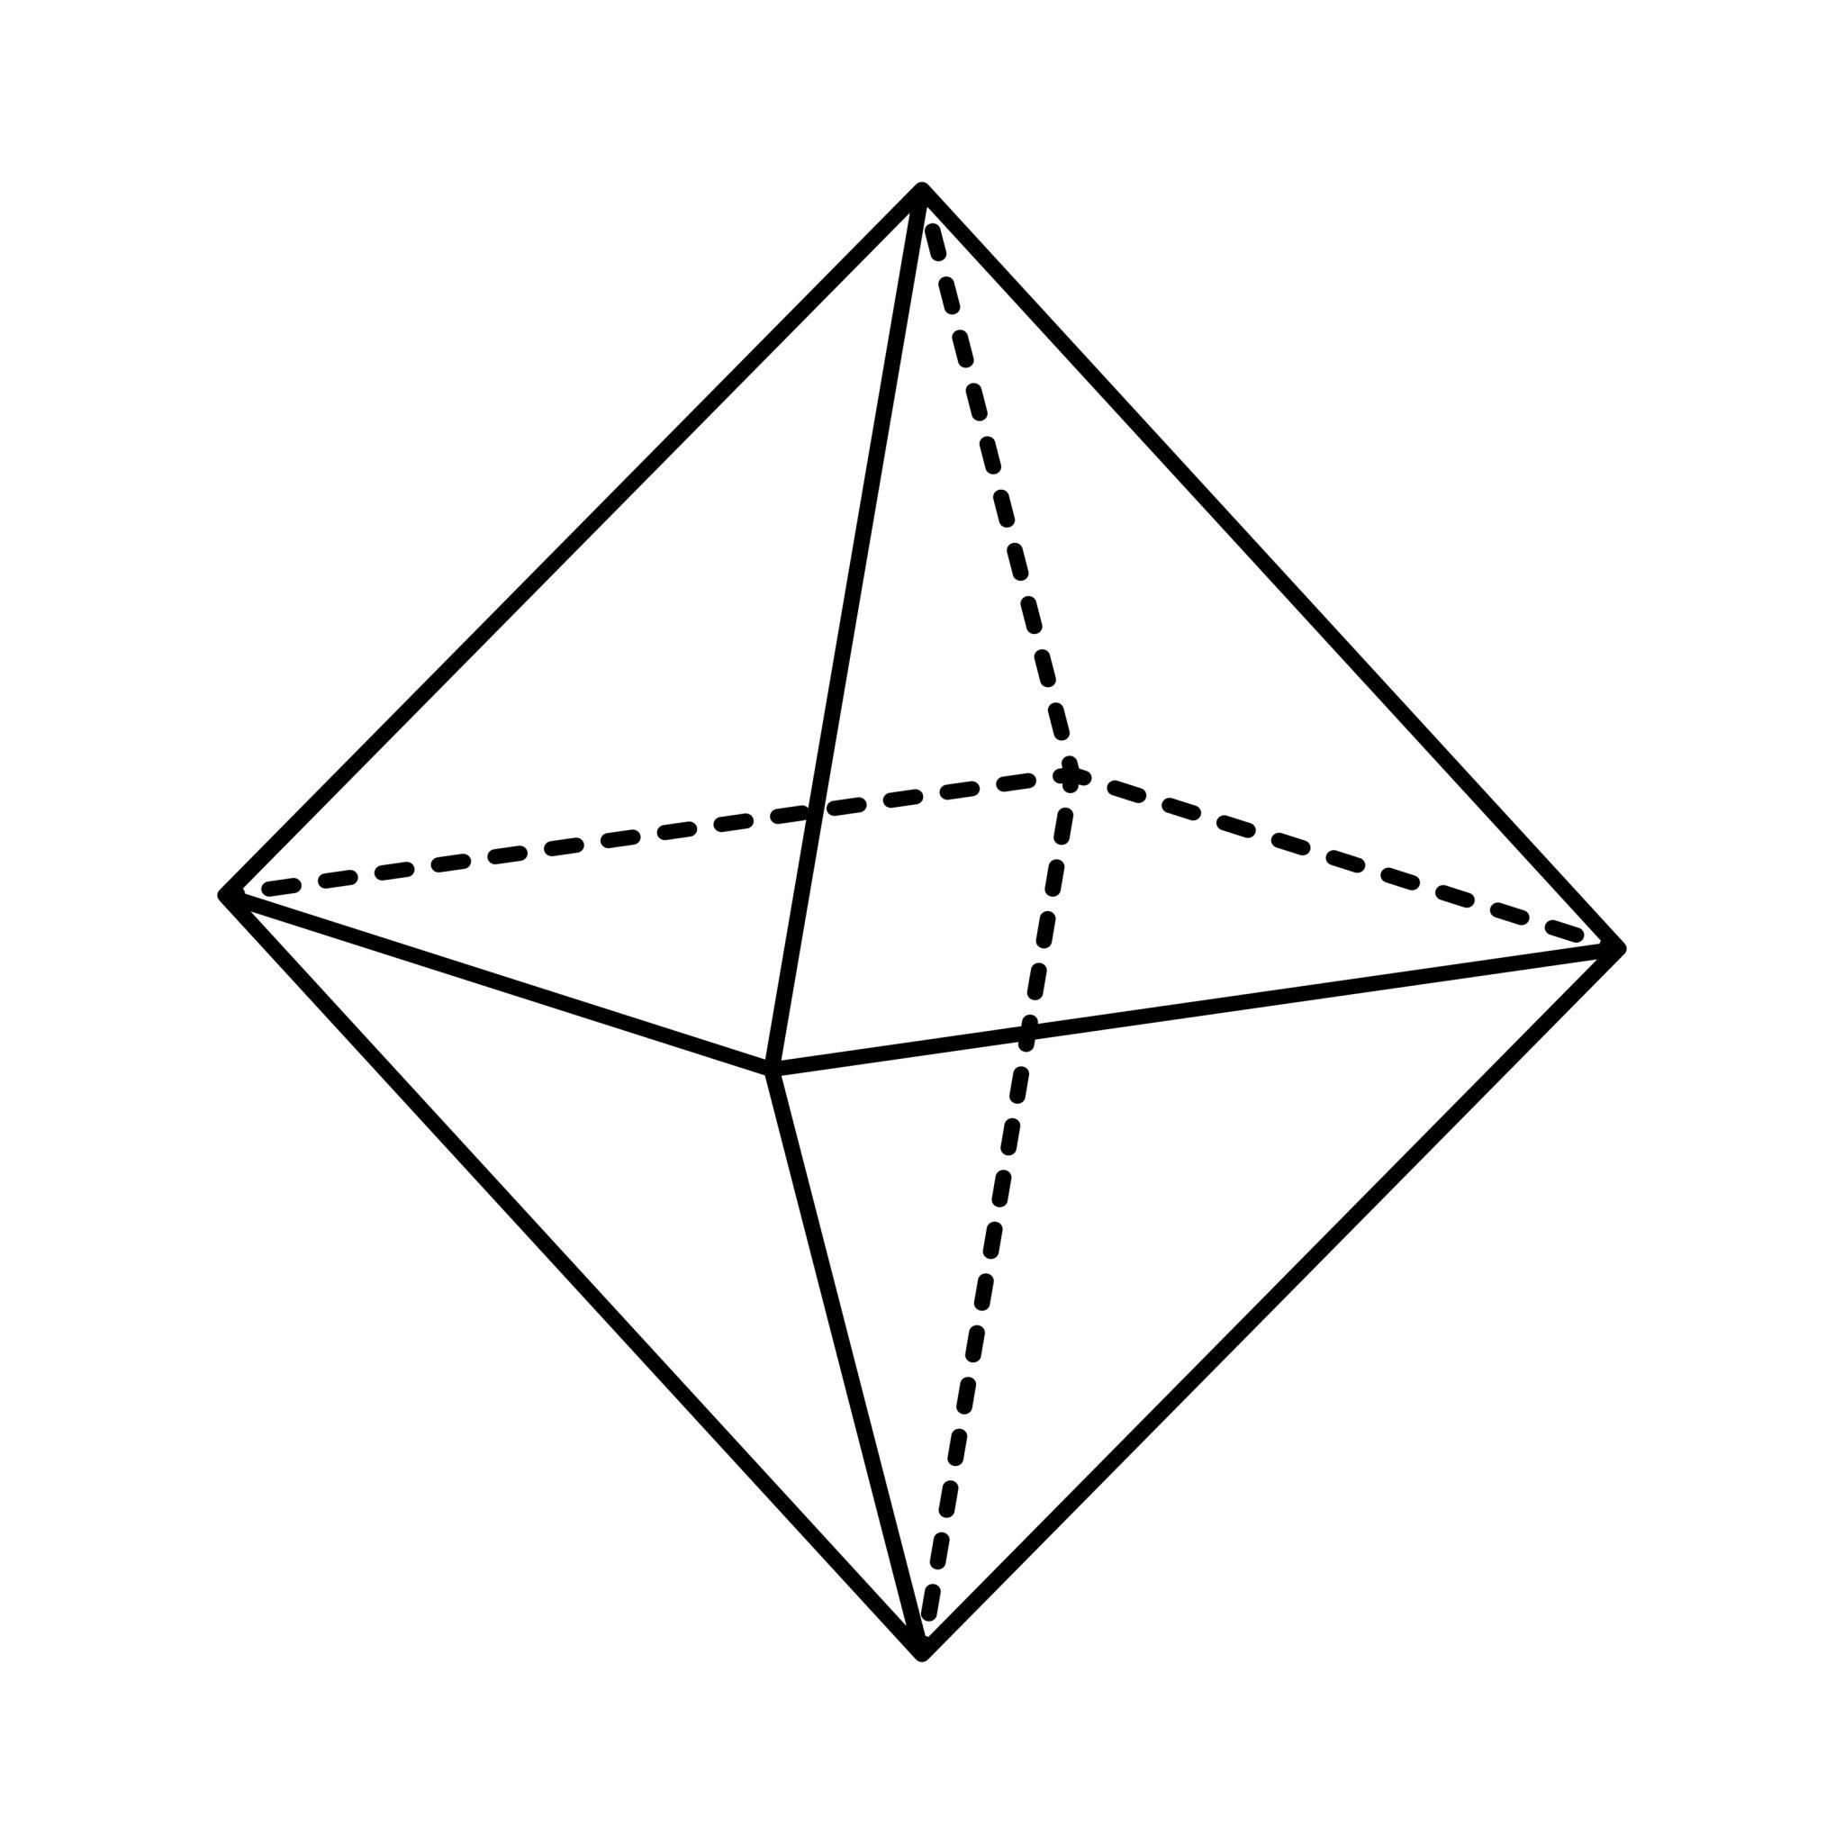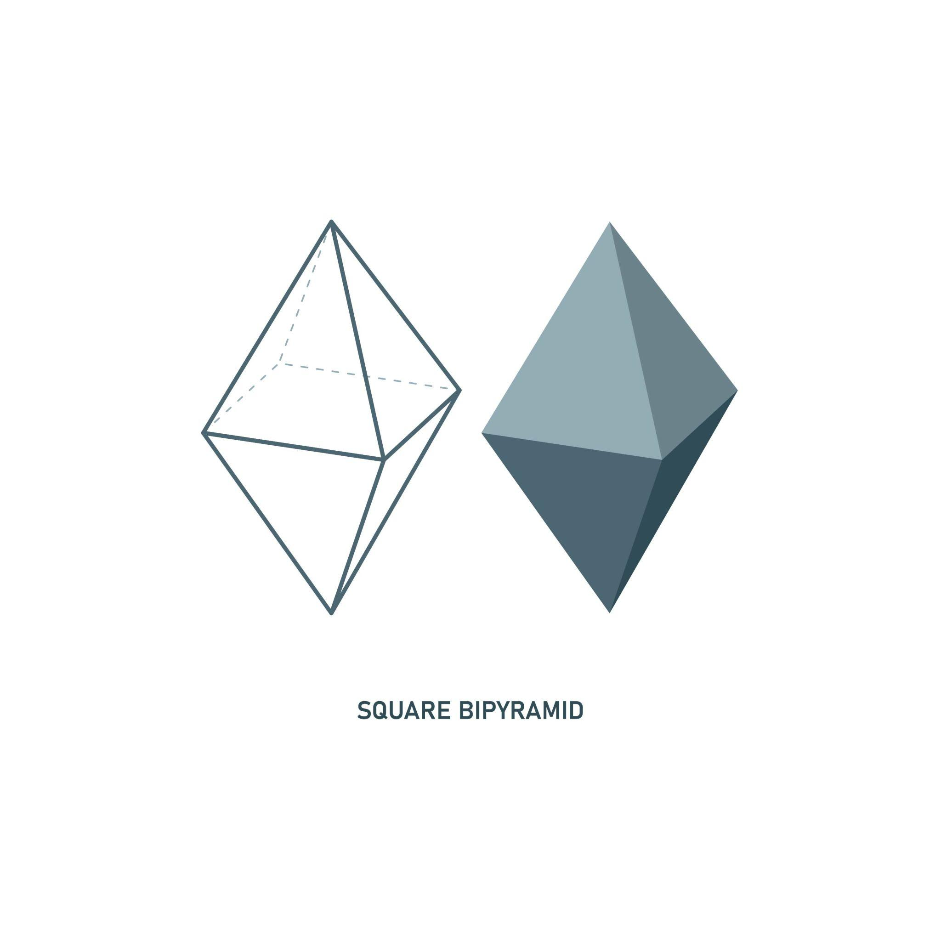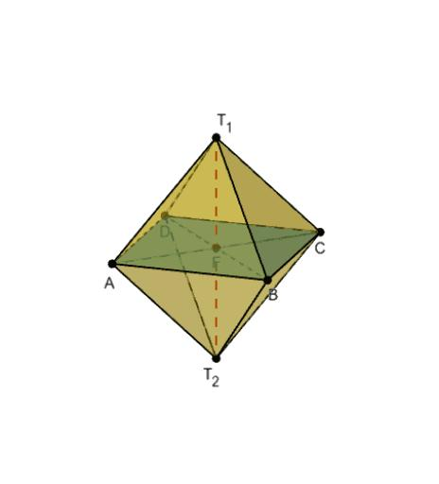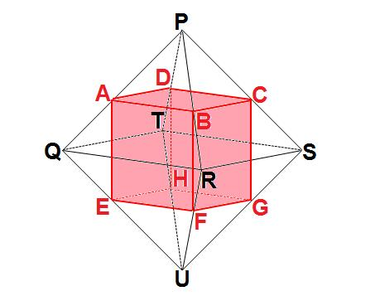

Geometric Structure
# Source: AI Source: Provided by: [Data Path: Persons Table -> ID Column: 1, Name_En Column: Motasem Essam] -> From: [ChatGPT] on [7/25/2026]
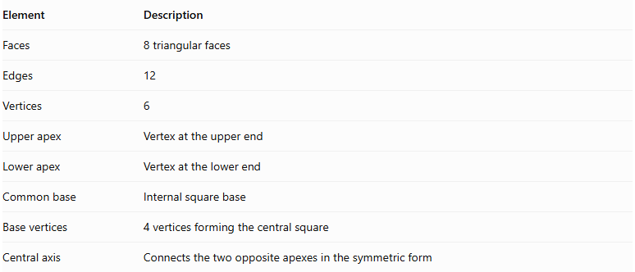
Element | Description
Faces | 8 triangular faces
Edges | 12
Vertices | 6
Upper apex | Vertex at the upper end
Lower apex | Vertex at the lower end
Common base | Internal square base
Base vertices | 4 vertices forming the central square
Central axis | Connects the two opposite apexes in the symmetric form
The common square base is an internal construction element and is not counted as an external face.

Face Structure
# Source: AI Source: Provided by: [Data Path: Persons Table -> ID Column: 1, Name_En Column: Motasem Essam] -> From: [ChatGPT] on [7/25/2026]
The square bipyramid has eight external triangular faces.
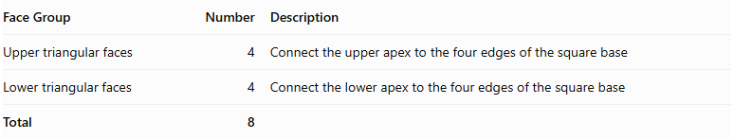
Face Group | Number | Description
Upper triangular faces | 4 | Connect the upper apex to the four edges of the square base
Lower triangular faces | 4 | Connect the lower apex to the four edges of the square base
Total | 8
In a regular octahedron, all eight triangular faces are equilateral.

Edge Structure
# Source: AI Source: Provided by: [Data Path: Persons Table -> ID Column: 1, Name_En Column: Motasem Essam] -> From: [ChatGPT] on [7/25/2026]
The square bipyramid has twelve edges:
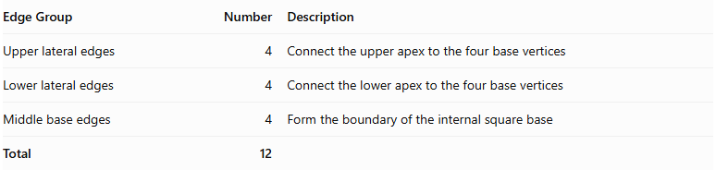
Edge Group | Number | Description
Upper lateral edges | 4 | Connect the upper apex to the four base vertices
Lower lateral edges | 4 | Connect the lower apex to the four base vertices
Middle base edges | 4 | Form the boundary of the internal square base
Total | 12

Vertex Structure
# Source: AI Source: Provided by: [Data Path: Persons Table -> ID Column: 1, Name_En Column: Motasem Essam] -> From: [ChatGPT] on [7/25/2026]
The square bipyramid has six vertices:
- 1 upper apex.
- 1 lower apex.
- 4 middle vertices forming the square base.
$$V=2+4=6$$
In its symmetric form:
- Four faces meet at each apex.
- Four faces meet at each middle vertex.

Mathematical Properties
# Source: AI Source: Provided by: [Data Path: Persons Table -> ID Column: 1, Name_En Column: Motasem Essam] -> From: [ChatGPT] on [7/25/2026]
For a square bipyramid:
$$n=4$$

A. Number of Faces
# Source: AI Source: Provided by: [Data Path: Persons Table -> ID Column: 1, Name_En Column: Motasem Essam] -> From: [ChatGPT] on [7/25/2026]
$$F=2n=2(4)=8$$

B. Number of Edges
# Source: AI Source: Provided by: [Data Path: Persons Table -> ID Column: 1, Name_En Column: Motasem Essam] -> From: [ChatGPT] on [7/25/2026]
$$E=3n=3(4)=12$$

C. Number of Vertices
# Source: AI Source: Provided by: [Data Path: Persons Table -> ID Column: 1, Name_En Column: Motasem Essam] -> From: [ChatGPT] on [7/25/2026]
$$V=n+2=4+2=6$$

D. Euler's Formula
# Source: AI Source: Provided by: [Data Path: Persons Table -> ID Column: 1, Name_En Column: Motasem Essam] -> From: [ChatGPT] on [7/25/2026]
$$V-E+F=2$$
$$6-12+8=2$$
<badge color="success">Verified</badge> Euler's formula is satisfied.

Surface Area and Volume
# Source: AI Source: Provided by: [Data Path: Persons Table -> ID Column: 1, Name_En Column: Motasem Essam] -> From: [ChatGPT] on [7/25/2026]
For a regular octahedron with edge length $s$:

A. Surface Area
# Source: AI Source: Provided by: [Data Path: Persons Table -> ID Column: 1, Name_En Column: Motasem Essam] -> From: [ChatGPT] on [7/25/2026]
Each face is an equilateral triangle:
$$A_{face}=\frac{\sqrt{3}}{4}s^{2}$$
Since there are eight faces:
$$SA=8(\frac{\sqrt{3}}{4}s^{2})$$
$$\boxed{SA=2\sqrt{3}s^{2}}$$

B. Volume
# Source: AI Source: Provided by: [Data Path: Persons Table -> ID Column: 1, Name_En Column: Motasem Essam] -> From: [ChatGPT] on [7/25/2026]
The volume of a regular octahedron is:
$$\boxed{V=\frac{\sqrt{2}}{3}s^{3}}$$
Alternatively, it can be calculated as the sum of the volumes of two square pyramids.
For square base area $B$, and upper and lower heights $h_{1},h_{2}$:
$$V=\frac{1}{3}B(h_{1}+h_{2})$$

Symmetry
# Source: AI Source: Provided by: [Data Path: Persons Table -> ID Column: 1, Name_En Column: Motasem Essam] -> From: [ChatGPT] on [7/25/2026]
A regular octahedron has:
- Fourfold rotational symmetry axes through opposite vertices.
- Threefold rotational symmetry axes through the centers of opposite faces.
- Twofold rotational symmetry axes through the midpoints of opposite edges.
- Nine reflection planes.
- Central inversion symmetry.
Its principal fourfold axis passes through the two opposite apexes of the square bipyramid.

Relationship to Other Solids
# Source: AI Source: Provided by: [Data Path: Persons Table -> ID Column: 1, Name_En Column: Motasem Essam] -> From: [ChatGPT] on [7/25/2026]
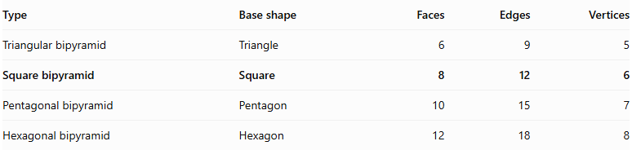
Type | Base shape | Faces | Edges | Vertices
Triangular bipyramid | Triangle | 6 | 9 | 5
Square bipyramid | Square | 8 | 12 | 6
Pentagonal bipyramid | Pentagon | 10 | 15 | 7
Hexagonal bipyramid | Hexagon | 12 | 18 | 8

Worked Examples
# Source: AI Source: Provided by: [Data Path: Persons Table -> ID Column: 1, Name_En Column: Motasem Essam] -> From: [ChatGPT] on [7/25/2026]
Example 1: Calculate the surface area of a regular octahedron.
Given:
$$s=4 cm$$
Using:
$$SA=2\sqrt{3}s^{2}$$
$$SA=2\sqrt{3}(4^{2})$$
$$\boxed{SA=32\sqrt{3}{ cm}^{2}}$$
Example 2: Calculate the volume of a regular octahedron.
Given:
$$s=3 cm$$
Using:
$$V=\frac{\sqrt{2}}{3}s^{3}$$
$$V=\frac{\sqrt{2}}{3}(3^{3})$$
$$\boxed{V=9\sqrt{2}{ cm}^{3}}$$

Constructing Square Bipyramid in Solid Geometry

Geometric Instruments Used
# Source: AI Source: Provided by: [Data Path: Persons Table -> ID Column: 1, Name_En Column: Motasem Essam] -> From: [ChatGPT] on [7/25/2026]
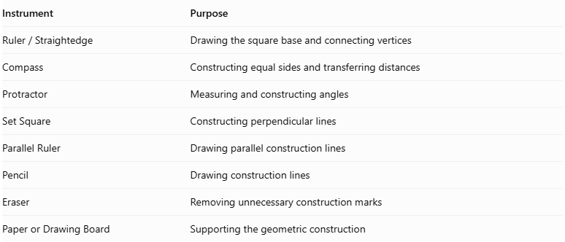
Instrument | Purpose
$$Ruler/Straightedge$$ | Drawing the square base and connecting vertices
Compass | Constructing equal sides and transferring distances
Protractor | Measuring and constructing angles
Set Square | Constructing perpendicular lines
Parallel Ruler | Drawing parallel construction lines
Pencil | Drawing construction lines
Eraser | Removing unnecessary construction marks
Paper or Drawing Board | Supporting the geometric construction

Instrument-Based Construction Procedures

Constructing the Equatorial Square
# Source: AI Source: Provided by: [Data Path: Persons Table -> ID Column: 1, Name_En Column: Motasem Essam] -> From: [ChatGPT] on [7/25/2026]
- Determine the required side length of the square.
- Draw one side using a ruler.
- Construct perpendicular lines at both endpoints using a set square.
- Mark equal side lengths on the perpendicular lines.
- Connect the remaining endpoints to complete the square.
- Label its vertices $A$, $B$, $C$, and $D$.

Locating the Two Apices
# Source: AI Source: Provided by: [Data Path: Persons Table -> ID Column: 1, Name_En Column: Motasem Essam] -> From: [ChatGPT] on [7/25/2026]
- Determine the intended positions of the two apices.
- Mark the upper apex as $P$.
- Mark the lower apex as $Q$.
- Position the two apices on opposite sides of the equatorial plane.
- For a symmetric square bipyramid, position the apices at equal perpendicular distances from the equatorial plane.

Connecting the Upper Apex
# Source: AI Source: Provided by: [Data Path: Persons Table -> ID Column: 1, Name_En Column: Motasem Essam] -> From: [ChatGPT] on [7/25/2026]
- Connect the upper apex $P$ to vertex $A$.
- Connect $P$ to vertex $B$.
- Connect $P$ to vertex $C$.
- Connect $P$ to vertex $D$.
- These connections form four upper triangular faces:
- Triangle $PAB$
- Triangle $PBC$
- Triangle $PCD$
- Triangle $PDA$

Connecting the Lower Apex
# Source: AI Source: Provided by: [Data Path: Persons Table -> ID Column: 1, Name_En Column: Motasem Essam] -> From: [ChatGPT] on [7/25/2026]
- Connect the lower apex $Q$ to vertex $A$.
- Connect $Q$ to vertex $B$.
- Connect $Q$ to vertex $C$.
- Connect $Q$ to vertex $D$.
- These connections form four lower triangular faces:
- Triangle $QAB$
- Triangle $QBC$
- Triangle $QCD$
- Triangle $QDA$

Completing the Square Bipyramid
# Source: AI Source: Provided by: [Data Path: Persons Table -> ID Column: 1, Name_En Column: Motasem Essam] -> From: [ChatGPT] on [7/25/2026]
- Draw all eight external triangular faces.
- Identify the visible and hidden edges.
- Use solid lines for visible edges.
- Use dashed lines for hidden edges when necessary.
- Verify that both square pyramids share the same equatorial square.
- Ensure that the shared square is internal rather than an external face.

Constructing a Regular Square Bipyramid
# Source: AI Source: Provided by: [Data Path: Persons Table -> ID Column: 1, Name_En Column: Motasem Essam] -> From: [ChatGPT] on [7/25/2026]
- Construct a square equatorial base with side length $a$.
- Locate the center of the square by constructing its diagonals.
- Construct a perpendicular line through the center of the square.
- Position the upper and lower apices symmetrically on opposite sides of the equatorial plane.
- Set each apex at a perpendicular distance of $a/\sqrt{2}$ from the equatorial plane.
- Connect each apex to all four square vertices.
- Verify that all eight external faces are equilateral triangles.
The resulting solid is a regular octahedron.

Constructing a Square Bipyramid Using a Net
# Source: AI Source: Provided by: [Data Path: Persons Table -> ID Column: 1, Name_En Column: Motasem Essam] -> From: [ChatGPT] on [7/25/2026]
- Construct eight triangular faces.
- Arrange four triangles around the upper pyramidal portion.
- Arrange four triangles around the lower pyramidal portion.
- Ensure that corresponding edges have matching lengths.
- Fold the triangles to form the two pyramidal portions.
- Join the corresponding edges to complete the square bipyramid.

Key Points
# Source: AI Source: Provided by: [Data Path: Persons Table -> ID Column: 1, Name_En Column: Motasem Essam] -> From: [ChatGPT] on [7/25/2026]
- A square bipyramid consists of two square pyramids joined at a common base.
- It has 8 external triangular faces.
- It has 12 edges and 6 vertices.
- Its common square base is internal.
- Four faces meet at every vertex in its symmetric form.
- Two congruent square pyramids produce an octahedron.
- When all eight faces are equilateral triangles, it becomes a regular octahedron.
- The regular octahedron is one of the five Platonic solids.

Conclusion
# Source: AI Source: Provided by: [Data Path: Persons Table -> ID Column: 1, Name_En Column: Motasem Essam] -> From: [ChatGPT] on [7/25/2026]
The Square Bipyramid is a bipyramid formed from two square-based pyramids joined base-to-base. It consists of eight triangular faces, twelve edges, and six vertices.
When the two pyramids are congruent and their eight faces are equilateral triangles, the resulting solid is a Regular Octahedron.
Classification note: Every regular octahedron is a square bipyramid, but not every square bipyramid is a regular octahedron.

